(1) Register an account on Google Code and log in the fluocell project home page;

Its URL is ‘https://code.google.com/p/fluocell/’;

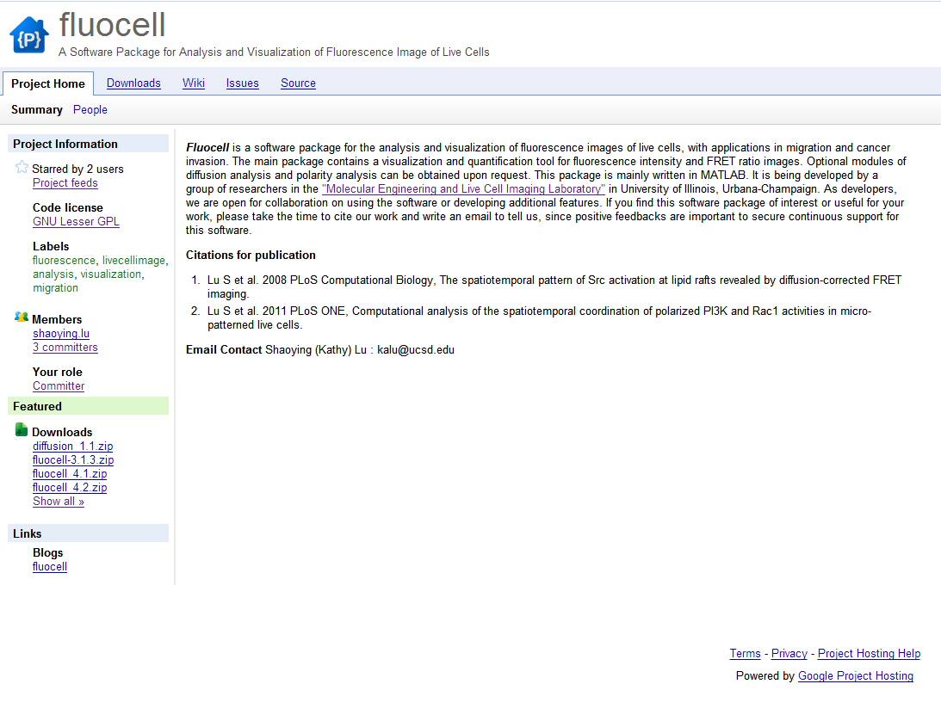

(2) Ask the project developer to add you in the committer group and get your own branch;

(3) Go to the Source\Browse\Branch to check if you have your own branch already;

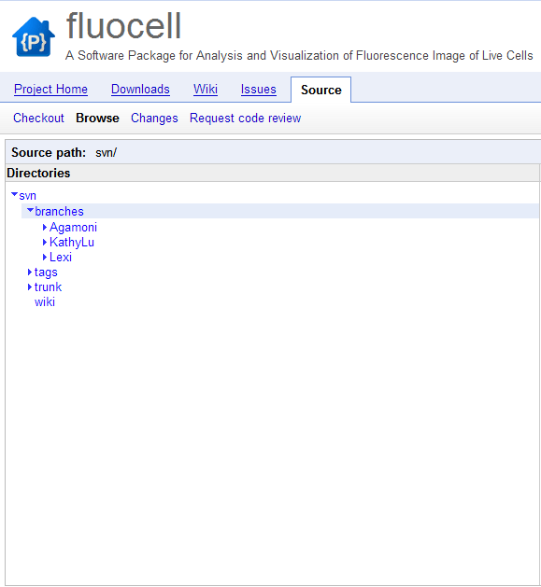

(4) Build a new working folder in your computer, then right click on this folder and choose the ‘SVN checkout’. You will see a window like below:

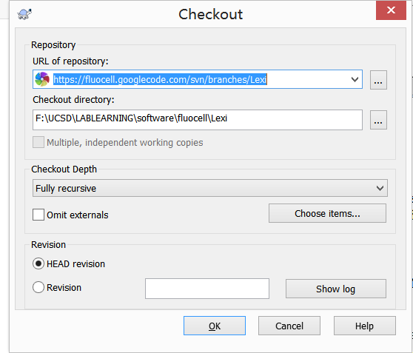

In the ‘URL of repository’ item, add the URL of your own branch then click ‘OK’ and wait the program to be downloaded in your working folder, it might take a few minutes;

(5) After downloading, you should check if there is a folder named ‘fluocell_4.3’ in your working folder, if there it is, follow the ‘Fluocell Use’s Guide’ to work with this tool.